ESP32: Guide for MicroSD Card Module using Arduino IDE
This guide shows how to use a microSD card with the ESP32: you’ll learn how to read and write files to the microSD card. To interface the microSD card with the ESP32 board, we’ll use a microSD card module (SPI communication protocol). Using a microSD card with the ESP32 is especially useful for data logging or storing files that don’t fit in the filesystem (SPIFFS). The ESP32 will be programmed using the Arduino core.
In this tutorial, we’ll cover the following topics:
- Introducing the MicroSD Card Module and Pinout
- Interface ESP32 with microSD Card Module
- Testing the microSD Card Module: read, write and handle files
- Use custom SPI pins with the microSD card
- ESP32 Data Logging to microSD Card (sensor readings)
- ESP32 Web Server with Files from microSD Card

MicroSD Card Module
There are different microSD card modules compatible with the ESP32. We’re using the microSD card module sown in the following figure – it communicates using SPI communication protocol. You can use any other microSD card module with an SPI interface.
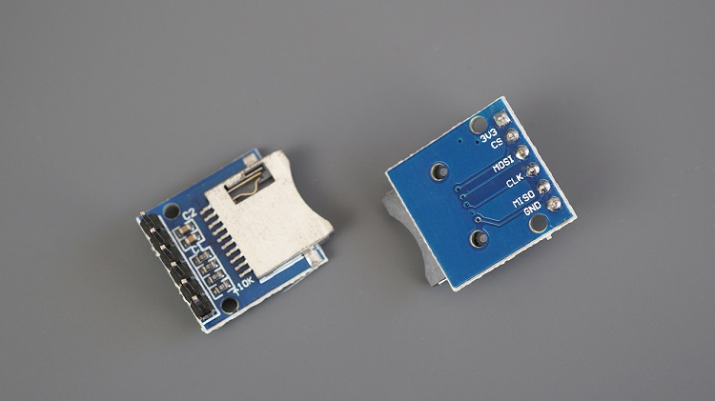
This microSD card module is also compatible with other microcontrollers like the Arduino and the ESP8266 NodeMCU boards. To learn how to use the microSD card module with the Arduino, you can follow the next tutorial:
- Guide to SD Card Module with Arduino

Where to Buy?
You can click the link below to check different stores where you can get the microSD card module:
- MicroSD card module
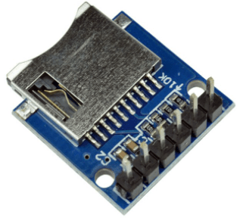

MicroSD Card Module Pinout – SPI
The microSD card module communicates using SPI communication protocol. You can connect it to the ESP32 using the default SPI pins.
MicroSD card module | ESP32
3V3 | 3.3V
CS | GPIO 5
MOSI | GPIO 23
CLK | GPIO 18
MISO | GPIO 19
GND | GND

Parts Required
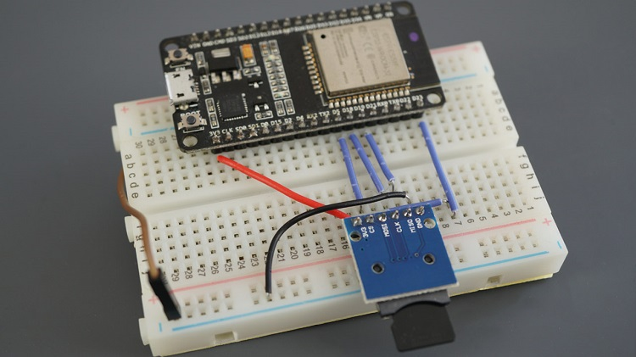
For this tutorial, you need the following parts:
- ESP32 development board (read: Best ESP32 development boards)
- MicroSD Card Module
- MicroSD Card
- Jumper Wires
- Breadboard
You can use the preceding links or go directly to MakerAdvisor.com/tools to find all the parts for your projects at the best price!

ESP32 with microSD Card Module – Schematic Diagram
To wire the microSD card module to the ESP32 board, you can follow the next schematic diagram (for the default ESP32 SPI pins):

Preparing the microSD Card
Before proceeding with the tutorial, make sure you format your microSD card as FAT32. Follow the next instructions to format your microSD card or use a software tool like SD Card Formater (compatible with Windows and Mac OS).
1. Insert the microSD card into your computer. Go to My Computer and right-click on the SD card. Select Format as shown in the figure below.
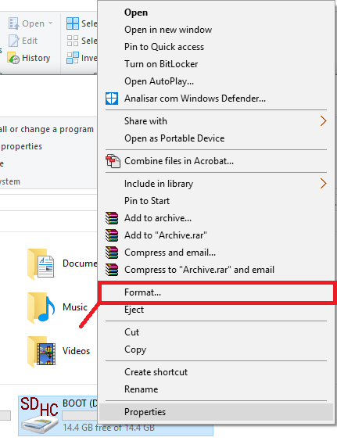2. A new window pops up. Select FAT32, press Start to initialize the formatting process and follow the onscreen instructions.
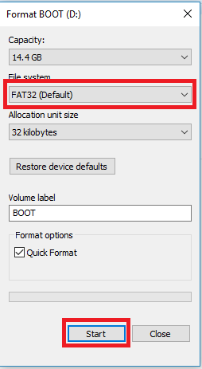

Preparing Arduino IDE
We’ll program the ESP32 board using Arduino IDE. So, make sure you have the ESP32 add-on installed. Follow the next tutorial:
- Install the ESP32 Board in Arduino IDE
If you prefer using VSCode + PlatformIO, follow the next tutorial instead:
- Getting Started with VS Code and PlatformIO IDE for ESP32 and ESP8266

ESP32 Handling Files with a MicroSD Card Module
There are two different libraries for the ESP32 (included in the Arduino core for the ESP32): the SD library and the SDD_MMC.h library.
If you use the SD library, you’re using the SPI controller. If you use the SDD_MMC library you’re using the ESP32 SD/SDIO/MMC controller. You can learn more about the ESP32 SD/SDIO/MMC driver.
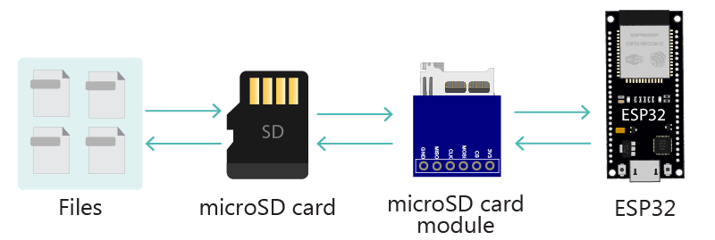
There are several examples in Arduino IDE that show how to handle files on the microSD card using the ESP32. In the Arduino IDE, go to File > Examples > SD(esp32) > SD_Test, or copy the following code.
/*
Rui Santos
Complete project details at https://RandomNerdTutorials.com/esp32-microsd-card-arduino/

/*
Rui Santos
Complete project details at https://RandomNerdTutorials.com/esp32-microsd-card-arduino/

This sketch can be found at: Examples > SD(esp32) > SD_Test
*/

#include "FS.h"
#include "SD.h"
#include "SPI.h"

void listDir(fs::FS &fs, const char * dirname, uint8_t levels){
Serial.printf("Listing directory: %s\n", dirname);

File root = fs.open(dirname);
if(!root){
Serial.println("Failed to open directory");
return;
}
if(!root.isDirectory()){
Serial.println("Not a directory");
return;
}

File file = root.openNextFile();
while(file){
if(file.isDirectory()){
Serial.print(" DIR : ");
Serial.println(file.name());
if(levels){
listDir(fs, file.name(), levels -1);
}
} else {
Serial.print(" FILE: ");
Serial.print(file.name());
Serial.print(" SIZE: ");
Serial.println(file.size());
}
file = root.openNextFile();
}
}

void createDir(fs::FS &fs, const char * path){
Serial.printf("Creating Dir: %s\n", path);
if(fs.mkdir(path)){
Serial.println("Dir created");
} else {
Serial.println("mkdir failed");
}
}

void removeDir(fs::FS &fs, const char * path){
Serial.printf("Removing Dir: %s\n", path);
if(fs.rmdir(path)){
Serial.println("Dir removed");
} else {
Serial.println("rmdir failed");
}
}

void readFile(fs::FS &fs, const char * path){
Serial.printf("Reading file: %s\n", path);

File file = fs.open(path);
if(!file){
Serial.println("Failed to open file for reading");
return;
}

Serial.print("Read from file: ");
while(file.available()){
Serial.write(file.read());
}
file.close();
}

void writeFile(fs::FS &fs, const char * path, const char * message){
Serial.printf("Writing file: %s\n", path);

File file = fs.open(path, FILE_WRITE);
if(!file){
Serial.println("Failed to open file for writing");
return;
}
if(file.print(message)){
Serial.println("File written");
} else {
Serial.println("Write failed");
}
file.close();
}

void appendFile(fs::FS &fs, const char * path, const char * message){
Serial.printf("Appending to file: %s\n", path);

File file = fs.open(path, FILE_APPEND);
if(!file){
Serial.println("Failed to open file for appending");
return;
}
if(file.print(message)){
Serial.println("Message appended");
} else {
Serial.println("Append failed");
}
file.close();
}

void renameFile(fs::FS &fs, const char * path1, const char * path2){
Serial.printf("Renaming file %s to %s\n", path1, path2);
if (fs.rename(path1, path2)) {
Serial.println("File renamed");
} else {
Serial.println("Rename failed");
}
}

void deleteFile(fs::FS &fs, const char * path){
Serial.printf("Deleting file: %s\n", path);
if(fs.remove(path)){
Serial.println("File deleted");
} else {
Serial.println("Delete failed");
}
}

void testFileIO(fs::FS &fs, const char * path){
File file = fs.open(path);
static uint8_t buf[512];
size_t len = 0;
uint32_t start = millis();
uint32_t end = start;
if(file){
len = file.size();
size_t flen = len;
start = millis();
while(len){
size_t toRead = len;
if(toRead > 512){
toRead = 512;
}
file.read(buf, toRead);
len -= toRead;
}
end = millis() - start;
Serial.printf("%u bytes read for %u ms\n", flen, end);
file.close();
} else {
Serial.println("Failed to open file for reading");
}

file = fs.open(path, FILE_WRITE);
if(!file){
Serial.println("Failed to open file for writing");
return;
}

size_t i;
start = millis();
for(i=0; i<2048; i++){
file.write(buf, 512);
}
end = millis() - start;
Serial.printf("%u bytes written for %u ms\n", 2048 * 512, end);
file.close();
}

void setup(){
Serial.begin(115200);
if(!SD.begin(5)){
Serial.println("Card Mount Failed");
return;
}
uint8_t cardType = SD.cardType();

if(cardType == CARD_NONE){
Serial.println("No SD card attached");
return;
}

Serial.print("SD Card Type: ");
if(cardType == CARD_MMC){
Serial.println("MMC");
} else if(cardType == CARD_SD){
Serial.println("SDSC");
} else if(cardType == CARD_SDHC){
Serial.println("SDHC");
} else {
Serial.println("UNKNOWN");
}

uint64_t cardSize = SD.cardSize() / (1024 * 1024);
Serial.printf("SD Card Size: %lluMB\n", cardSize);

listDir(SD, "/", 0);
createDir(SD, "/mydir");
listDir(SD, "/", 0);
removeDir(SD, "/mydir");
listDir(SD, "/", 2);
writeFile(SD, "/hello.txt", "Hello ");
appendFile(SD, "/hello.txt", "World!\n");
readFile(SD, "/hello.txt");
deleteFile(SD, "/foo.txt");
renameFile(SD, "/hello.txt", "/foo.txt");
readFile(SD, "/foo.txt");
testFileIO(SD, "/test.txt");
Serial.printf("Total space: %lluMB\n", SD.totalBytes() / (1024 * 1024));
Serial.printf("Used space: %lluMB\n", SD.usedBytes() / (1024 * 1024));
}

void loop(){

}
This example shows how to do almost any task you may need with the microSD card:
- List a directory;
- Create a directory;
- Remove a directory;
- Read a file content;
- Write content to a file;
- Append content to file;
- Rename a file;
- Delete a file;
- Initialize microSD card;
- Get microSD card type;
- Get microSD card size;
Alternatively, you can use the SD_MMC examples – these are similar to the SD examples, but use the SDMMC driver. For the SDMMC driver, you need a compatible microSD card module. The module we’re using in this tutorial doesn’t support SDMMC.

How the Code Works
First, you need to include the following libraries: FS.h to handle files, SD.h to interface with the microSD card and SPI.h to use SPI communication protocol.
#include "FS.h"
#include "SD.h"
#include "SPI.h"
The example provides several functions to handle files on the microSD card.

List a directory
The listDir() function lists the directories on the SD card. This function accepts as arguments the filesystem (SD), the main directory’s name, and the levels to go into the directory.
void listDir(fs::FS &fs, const char * dirname, uint8_t levels){
Serial.printf("Listing directory: %s\n", dirname);

File root = fs.open(dirname);
if(!root){
Serial.println("Failed to open directory");
return;
}
if(!root.isDirectory()){
Serial.println("Not a directory");
return;
}

File file = root.openNextFile();
while(file){
if(file.isDirectory()){
Serial.print(" DIR : ");
Serial.println(file.name());
if(levels){
listDir(fs, file.name(), levels -1);
}
} else {
Serial.print(" FILE: ");
Serial.print(file.name());
Serial.print(" SIZE: ");
Serial.println(file.size());
}
file = root.openNextFile();
}
}
Here’s an example of how to call this function. The / corresponds to the microSD card root directory.
listDir(SD, "/", 0);

Create a Directory
The createDir() function creates a new directory. Pass as an argument the SD filesystem and the directory name path.
void createDir(fs::FS &fs, const char * path){
Serial.printf("Creating Dir: %s\n", path);
if(fs.mkdir(path)){
Serial.println("Dir created");
} else {
Serial.println("mkdir failed");
}
}
For example, the following command creates a new directory on the root called mydir.
createDir(SD, "/mydir");

Remove a Directory
To remove a directory from the microSD card, use the removeDir() function and pass as an argument the SD filesystem and the directory name path.
void removeDir(fs::FS &fs, const char * path){
Serial.printf("Removing Dir: %s\n", path);
if(fs.rmdir(path)){
Serial.println("Dir removed");
} else {
Serial.println("rmdir failed");
}
}
Here is an example:
removeDir(SD, "/mydir");

Read File Content
The readFile() function reads the content of a file and prints the content in the Serial Monitor. As with previous functions, pass as an argument the SD filesystem and the file path.
void readFile(fs::FS &fs, const char * path){
Serial.printf("Reading file: %s\n", path);

File file = fs.open(path);
if(!file){
Serial.println("Failed to open file for reading");
return;
}

Serial.print("Read from file: ");
while(file.available()){
Serial.write(file.read());
}
file.close();
}
For example, the following line reads the content of the hello.txt file.
readFile(SD, "/hello.txt")

Write Content to a File
To write content to a file, you can use the writeFile() function. Pass as an argument, the SD filesystem, the file path and the message
void writeFile(fs::FS &fs, const char * path, const char * message){
Serial.printf("Writing file: %s\n", path);

File file = fs.open(path, FILE_WRITE);
if(!file){
Serial.println("Failed to open file for writing");
return;
}
if(file.print(message)){
Serial.println("File written");
} else {
Serial.println("Write failed");
}
file.close();
}
The following line writes Hello in the hello.txt file.
writeFile(SD, "/hello.txt", "Hello ");

Append Content to a File
Similarly, you can append content to a file (without overwriting previous content) using the appendFile() function.
void appendFile(fs::FS &fs, const char * path, const char * message){
Serial.printf("Appending to file: %s\n", path);

File file = fs.open(path, FILE_APPEND);
if(!file){
Serial.println("Failed to open file for appending");
return;
}
if(file.print(message)){
Serial.println("Message appended");
} else {
Serial.println("Append failed");
}
file.close();
}
The following line appends the message World!\n in the hello.txt file. The \n means that the next time you write something to the file, it will be written in a new line.
appendFile(SD, "/hello.txt", "World!\n");

Rename a File
You can rename a file using the renameFile() function. Pass as arguments the SD filesystem, the original filename, and the new filename.
void renameFile(fs::FS &fs, const char * path1, const char * path2){
Serial.printf("Renaming file %s to %s\n", path1, path2);
if (fs.rename(path1, path2)) {
Serial.println("File renamed");
} else {
Serial.println("Rename failed");
}
}
The following line renames the hello.txt file to foo.txt.
renameFile(SD, "/hello.txt", "/foo.txt");

Delete a File
Use the deleteFile() function to delete a file. Pass as an argument the SD filesystem and the file path of the file you want to delete.
void deleteFile(fs::FS &fs, const char * path){
Serial.printf("Deleting file: %s\n", path);
if(fs.remove(path)){
Serial.println("File deleted");
} else {
Serial.println("Delete failed");
}
}
The following line deletes the foo.txt file from the microSD card.
deleteFile(SD, "/foo.txt");

Test a File
The testFileIO() functions shows how long it takes to read the content of a file.
void testFileIO(fs::FS &fs, const char * path){
File file = fs.open(path);
static uint8_t buf[512];
size_t len = 0;
uint32_t start = millis();
uint32_t end = start;
if(file){
len = file.size();
size_t flen = len;
start = millis();
while(len){
size_t toRead = len;
if(toRead > 512){
toRead = 512;
}
file.read(buf, toRead);
len -= toRead;
}
end = millis() - start;
Serial.printf("%u bytes read for %u ms\n", flen, end);
file.close();
}
else {
Serial.println("Failed to open file for reading");
}

file = fs.open(path, FILE_WRITE);
if(!file){
Serial.println("Failed to open file for writing");
return;
}

size_t i;
start = millis();
for(i=0; i<2048; i++){
file.write(buf, 512);
}
end = millis() - start;
Serial.printf("%u bytes written for %u ms\n", 2048 * 512, end);
file.close();
}
The following function tests the test.txt file.
testFileIO(SD, "/test.txt");

Initialize the microSD Card
In the setup(), the following lines initialize the microSD card with SD.begin().
Serial.begin(115200);
if(!SD.begin()){
Serial.println("Card Mount Failed");
return;
}
uint8_t cardType = SD.cardType();

if(cardType == CARD_NONE){
Serial.println("No SD card attached");
return;
}
If you don’t pass any argument to the begin() function, it will try to initialize SPI communication with the microSD card on the default chip select (CS) pin. If you want to use another CS pin, you can pass it as an argument to the begin() function. For example, if you wanted to use GPIO 17 as a CS pin, you should use the following lines of code:
Serial.begin(115200);
if(!SD.begin(17)){
Serial.println("Card Mount Failed");
return;
}
uint8_t cardType = SD.cardType();
If you want to use custom SPI pins with the microSD card, go to this section.

Get microSD Card Type
The following lines print the microSD card type on the Serial Monitor.
Serial.print("SD Card Type: ");
if(cardType == CARD_MMC){
Serial.println("MMC");
} else if(cardType == CARD_SD){
Serial.println("SDSC");
} else if(cardType == CARD_SDHC){
Serial.println("SDHC");
} else {
Serial.println("UNKNOWN");
}

Get microSD Card Size
You can get the microSD card size by calling the cardSize() method:
uint64_t cardSize = SD.cardSize() / (1024 * 1024);
Serial.printf("SD Card Size: %lluMB\n", cardSize);

Testing MicroSD Card Functions
The following lines call the functions we’ve seen previously.
listDir(SD, "/", 0);
createDir(SD, "/mydir");
listDir(SD, "/", 0);
removeDir(SD, "/mydir");
listDir(SD, "/", 2);
writeFile(SD, "/hello.txt", "Hello ");
appendFile(SD, "/hello.txt", "World!\n");
readFile(SD, "/hello.txt");
deleteFile(SD, "/foo.txt");
renameFile(SD, "/hello.txt", "/foo.txt");
readFile(SD, "/foo.txt");
testFileIO(SD, "/test.txt");
Serial.printf("Total space: %lluMB\n", SD.totalBytes() / (1024 * 1024));
Serial.printf("Used space: %lluMB\n", SD.usedBytes() / (1024 * 1024));

Demonstration
Upload the previous sketch to your ESP32 board. After that, open the Serial Monitor and press the ESP32 on-board RST button. If the initialization succeeds, you’ll get similar messages on the Serial Monitor.
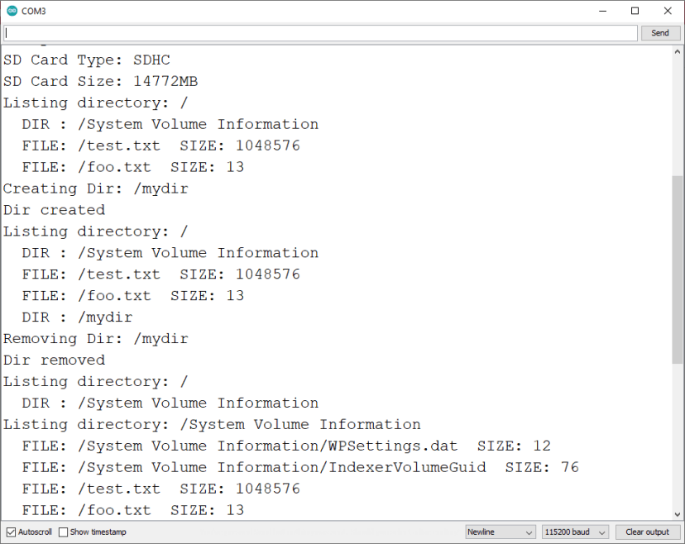
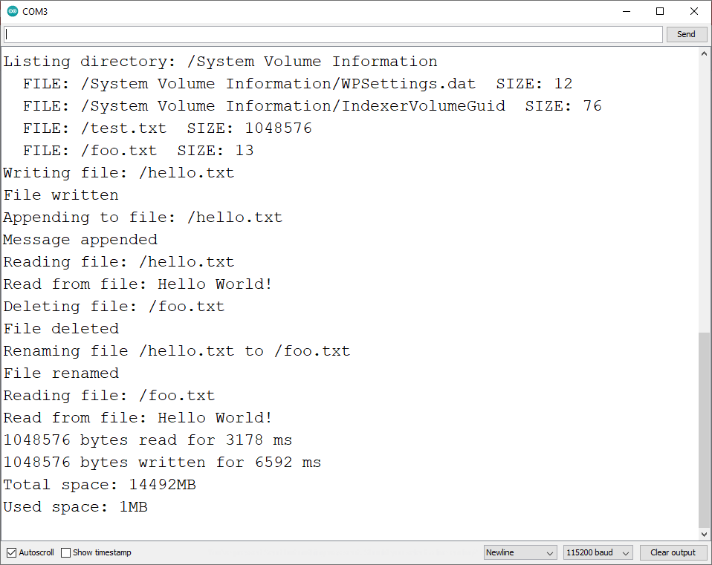

Use Custom SPI Pins with the MicroSD Card
The SD.h and SD_MMC.h libraries use the VSPI SPI pins (23, 19, 18, 5) by default. You can set other pins as SPI pins. The ESP32 features two SPI interfaces: HSPI and VSPI on the following pins:

SPI | MOSI | MISO | CLK | CS
VSPI | GPIO 23 | GPIO 19 | GPIO 18 | GPIO 5
HSPI | GPIO 13 | GPIO 12 | GPIO 14 | GPIO 15
Recommended reading: ESP32 Pinout Reference: Which GPIO pins should you use?
To use other SPI pins, you can proceed as follows:
At the beginning of your code, declare the pins you want to use, for example:
#define SCK 17
#define MISO 19
#define MOSI 23
#define CS 5
In the setup(), create a new SPI class on HSPI or VSPI. We’re using VSPI. Both will work fine.
SPIClass spi = SPIClass(VSPI);
Initialize SPI communication protocol on the pins defined previously:
spi.begin(SCK, MISO, MOSI, CS);
Finally, initialize the microSD card with the begin() method. Pass as argument the CS pin, the SPI instance you want to use, and the bus frequency.
if (!SD.begin(CS,spi,80000000)) {
Serial.println("Card Mount Failed");
return;
}
Here is the sample code modified to use custom SPI pins:
/*
Rui Santos
Complete project details at https://RandomNerdTutorials.com/esp32-microsd-card-arduino/

This sketch was mofidied from: Examples > SD(esp32) > SD_Test
*/

#include "FS.h"
#include "SD.h"
#include "SPI.h"

#define SCK 17
#define MISO 19
#define MOSI 23
#define CS 5

void listDir(fs::FS &fs, const char * dirname, uint8_t levels){
Serial.printf("Listing directory: %s\n", dirname);

File root = fs.open(dirname);
if(!root){
Serial.println("Failed to open directory");
return;
}
if(!root.isDirectory()){
Serial.println("Not a directory");
return;
}

File file = root.openNextFile();
while(file){
if(file.isDirectory()){
Serial.print(" DIR : ");
Serial.println(file.name());
if(levels){
listDir(fs, file.name(), levels -1);
}
} else {
Serial.print(" FILE: ");
Serial.print(file.name());
Serial.print(" SIZE: ");
Serial.println(file.size());
}
file = root.openNextFile();
}
}

void createDir(fs::FS &fs, const char * path){
Serial.printf("Creating Dir: %s\n", path);
if(fs.mkdir(path)){
Serial.println("Dir created");
} else {
Serial.println("mkdir failed");
}
}

void removeDir(fs::FS &fs, const char * path){
Serial.printf("Removing Dir: %s\n", path);
if(fs.rmdir(path)){
Serial.println("Dir removed");
} else {
Serial.println("rmdir failed");
}
}

void readFile(fs::FS &fs, const char * path){
Serial.printf("Reading file: %s\n", path);

File file = fs.open(path);
if(!file){
Serial.println("Failed to open file for reading");
return;
}

Serial.print("Read from file: ");
while(file.available()){
Serial.write(file.read());
}
file.close();
}

void writeFile(fs::FS &fs, const char * path, const char * message){
Serial.printf("Writing file: %s\n", path);

File file = fs.open(path, FILE_WRITE);
if(!file){
Serial.println("Failed to open file for writing");
return;
}
if(file.print(message)){
Serial.println("File written");
} else {
Serial.println("Write failed");
}
file.close();
}

void appendFile(fs::FS &fs, const char * path, const char * message){
Serial.printf("Appending to file: %s\n", path);

File file = fs.open(path, FILE_APPEND);
if(!file){
Serial.println("Failed to open file for appending");
return;
}
if(file.print(message)){
Serial.println("Message appended");
} else {
Serial.println("Append failed");
}
file.close();
}

void renameFile(fs::FS &fs, const char * path1, const char * path2){
Serial.printf("Renaming file %s to %s\n", path1, path2);
if (fs.rename(path1, path2)) {
Serial.println("File renamed");
} else {
Serial.println("Rename failed");
}
}

void deleteFile(fs::FS &fs, const char * path){
Serial.printf("Deleting file: %s\n", path);
if(fs.remove(path)){
Serial.println("File deleted");
} else {
Serial.println("Delete failed");
}
}

void testFileIO(fs::FS &fs, const char * path){
File file = fs.open(path);
static uint8_t buf[512];
size_t len = 0;
uint32_t start = millis();
uint32_t end = start;
if(file){
len = file.size();
size_t flen = len;
start = millis();
while(len){
size_t toRead = len;
if(toRead > 512){
toRead = 512;
}
file.read(buf, toRead);
len -= toRead;
}
end = millis() - start;
Serial.printf("%u bytes read for %u ms\n", flen, end);
file.close();
} else {
Serial.println("Failed to open file for reading");
}

file = fs.open(path, FILE_WRITE);
if(!file){
Serial.println("Failed to open file for writing");
return;
}

size_t i;
start = millis();
for(i=0; i<2048; i++){
file.write(buf, 512);
}
end = millis() - start;
Serial.printf("%u bytes written for %u ms\n", 2048 * 512, end);
file.close();
}

void setup(){
Serial.begin(115200);
SPIClass spi = SPIClass(VSPI);
spi.begin(SCK, MISO, MOSI, CS);

if (!SD.begin(CS,spi,80000000)) {
Serial.println("Card Mount Failed");
return;
}
uint8_t cardType = SD.cardType();

if(cardType == CARD_NONE){
Serial.println("No SD card attached");
return;
}

Serial.print("SD Card Type: ");
if(cardType == CARD_MMC){
Serial.println("MMC");
} else if(cardType == CARD_SD){
Serial.println("SDSC");
} else if(cardType == CARD_SDHC){
Serial.println("SDHC");
} else {
Serial.println("UNKNOWN");
}

uint64_t cardSize = SD.cardSize() / (1024 * 1024);
Serial.printf("SD Card Size: %lluMB\n", cardSize);

listDir(SD, "/", 0);
createDir(SD, "/mydir");
listDir(SD, "/", 0);
removeDir(SD, "/mydir");
listDir(SD, "/", 2);
writeFile(SD, "/hello.txt", "Hello ");
appendFile(SD, "/hello.txt", "World!\n");
readFile(SD, "/hello.txt");
deleteFile(SD, "/foo.txt");
renameFile(SD, "/hello.txt", "/foo.txt");
readFile(SD, "/foo.txt");
testFileIO(SD, "/test.txt");
Serial.printf("Total space: %lluMB\n", SD.totalBytes() / (1024 * 1024));
Serial.printf("Used space: %lluMB\n", SD.usedBytes() / (1024 * 1024));
}

void loop(){

}

Example: ESP32 Data Logging to microSD Card
Using a microSD card is especially useful for data logging projects. As an example, we’ll show you how to save sensor readings from a BME280 sensor with timestamps (epoch time).

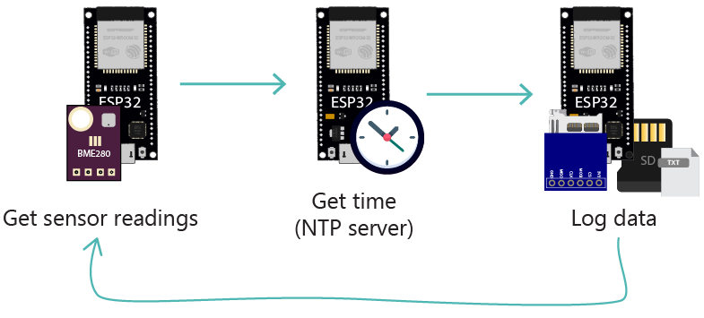
Prerequisites
For this example, make sure you have the following libraries installed:
- Adafruit BME280 Library
- Adafruit Unified Sensor Driver
You can install these libraries using the Arduino library manager. In your Arduino IDE, go to Sketch > Include Library > Manage Libraries… Then, search for the library names and install them.
If you’re using VS Code with PlatformIO, copy the following lines to the platformio.ini file to include all the necessary libraries.
lib_deps = adafruit/Adafruit BME280 Library @ ^2.1.0
adafruit/Adafruit Unified Sensor @ ^1.1.4

Schematic Diagram
For this example, you need to wire the microSD card module and the BME280 sensor to the ESP32. Here’s a list of the parts required:
- ESP32 development board (read: Best ESP32 development boards)
- BME280 sensor
- MicroSD Card Module
- MicroSD Card
- Jumper Wires
- Breadboard
Wire the circuit by following the next schematic diagram.
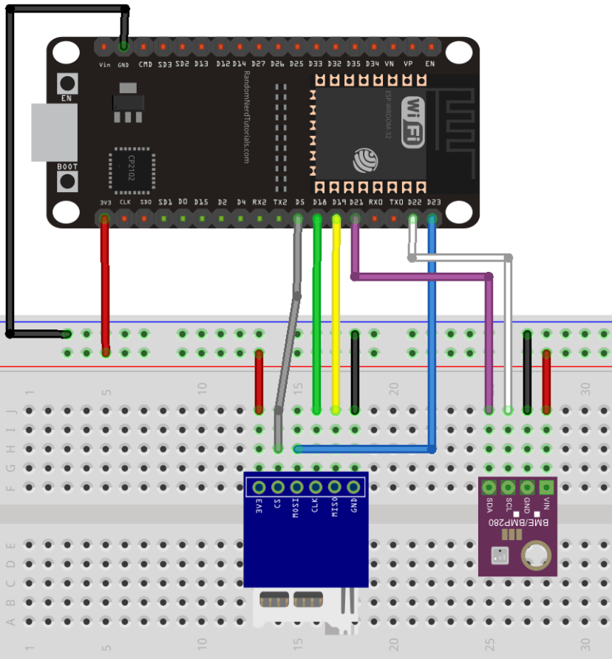
You can also take a look at the following tables:
BME280 | ESP32
VIN | 3V3
GND | GND
SCL | GPIO 22
SDA | GPIO 21
microSD card module | ESP32
3V3 | 3.3V
CS | GPIO 5
MOSI | GPIO 23
CLK | GPIO 18
MISO | GPIO 19
GND | GND

Code
Copy the following code to your Arduino IDE. This sketch gets BME280 sensor readings (temperature, humidity, and pressure) and logs them in a file on the microSD card every 30 seconds. It also logs the timestamp (epoch time requested to an NTP server).
/*
Rui Santos
Complete project details at https://RandomNerdTutorials.com/esp32-microsd-card-arduino/

Permission is hereby granted, free of charge, to any person obtaining a copy
of this software and associated documentation files.

The above copyright notice and this permission notice shall be included in all
copies or substantial portions of the Software.
*/

// Libraries for SD card
#include "FS.h"
#include "SD.h"
#include <SPI.h>

//Libraries for BME280 sensor
#include <Adafruit_Sensor.h>
#include <Adafruit_BME280.h>

// Libraries to get time from NTP Server
#include <WiFi.h>
#include "time.h"

// Replace with your network credentials
const char* ssid = "REPLACE_WITH_YOUR_SSID";
const char* password = "REPLACE_WITH_YOUR_PASSWORD";

// Timer variables
unsigned long lastTime = 0;
unsigned long timerDelay = 30000;

// BME280 I2C
Adafruit_BME280 bme;

// Variables to hold sensor readings
float temp;
float hum;
float pres;
String dataMessage;

// NTP server to request epoch time
const char* ntpServer = "pool.ntp.org";

// Variable to save current epoch time
unsigned long epochTime;

// Function that gets current epoch time
unsigned long getTime() {
time_t now;
struct tm timeinfo;
if (!getLocalTime(&timeinfo)) {
//Serial.println("Failed to obtain time");
return(0);
}
time(&now);
return now;
}

// Initialize WiFi
void initWiFi() {
WiFi.mode(WIFI_STA);
WiFi.begin(ssid, password);
Serial.print("Connecting to WiFi ..");
while (WiFi.status() != WL_CONNECTED) {
Serial.print('.');
delay(1000);
}
Serial.println(WiFi.localIP());
}

// Init BME280
void initBME(){
if (!bme.begin(0x76)) {
Serial.println("Could not find a valid BME280 sensor, check wiring!");
while (1);
}
}

// Initialize SD card
void initSDCard(){
if (!SD.begin()) {
Serial.println("Card Mount Failed");
return;
}
uint8_t cardType = SD.cardType();

if(cardType == CARD_NONE){
Serial.println("No SD card attached");
return;
}
Serial.print("SD Card Type: ");
if(cardType == CARD_MMC){
Serial.println("MMC");
} else if(cardType == CARD_SD){
Serial.println("SDSC");
} else if(cardType == CARD_SDHC){
Serial.println("SDHC");
} else {
Serial.println("UNKNOWN");
}
uint64_t cardSize = SD.cardSize() / (1024 * 1024);
Serial.printf("SD Card Size: %lluMB\n", cardSize);
}

// Write to the SD card
void writeFile(fs::FS &fs, const char * path, const char * message) {
Serial.printf("Writing file: %s\n", path);

File file = fs.open(path, FILE_WRITE);
if(!file) {
Serial.println("Failed to open file for writing");
return;
}
if(file.print(message)) {
Serial.println("File written");
} else {
Serial.println("Write failed");
}
file.close();
}

// Append data to the SD card
void appendFile(fs::FS &fs, const char * path, const char * message) {
Serial.printf("Appending to file: %s\n", path);

File file = fs.open(path, FILE_APPEND);
if(!file) {
Serial.println("Failed to open file for appending");
return;
}
if(file.print(message)) {
Serial.println("Message appended");
} else {
Serial.println("Append failed");
}
file.close();
}

void setup() {
Serial.begin(115200);

initWiFi();
initBME();
initSDCard();
configTime(0, 0, ntpServer);

// If the data.txt file doesn't exist
// Create a file on the SD card and write the data labels
File file = SD.open("/data.txt");
if(!file) {
Serial.println("File doesn't exist");
Serial.println("Creating file...");
writeFile(SD, "/data.txt", "Epoch Time, Temperature, Humidity, Pressure \r\n");
}
else {
Serial.println("File already exists");
}
file.close();
}

void loop() {
if ((millis() - lastTime) > timerDelay) {
//Get epoch time
epochTime = getTime();

//Get sensor readings
temp = bme.readTemperature();
//temp = 1.8*bme.readTemperature() + 32;
hum = bme.readHumidity();
pres = bme.readPressure()/100.0F;

//Concatenate all info separated by commas
dataMessage = String(epochTime) + "," + String(temp) + "," + String(hum) + "," + String(pres)+ "\r\n";
Serial.print("Saving data: ");
Serial.println(dataMessage);

//Append the data to file
appendFile(SD, "/data.txt", dataMessage.c_str());

lastTime = millis();
}
}
Insert your network credentials in the following variables and the code will work straight away:
const char* ssid = "REPLACE_WITH_YOUR_SSID";
const char* password = "REPLACE_WITH_YOUR_PASSWORD";
This example uses the functions we’ve seen previously to write and append data to the microSD card (writeFile() and appendFile() functions).
To better understand how this example works, we recommend taking a look at the following tutorials:
- Get Epoch/Unix Time with the ESP32 (Arduino)
- ESP32 with BME280 Sensor using Arduino IDE (Pressure, Temperature, Humidity)

Demonstration
Upload the code to your board. You can check on the Serial Monitor if everything is working as expected.
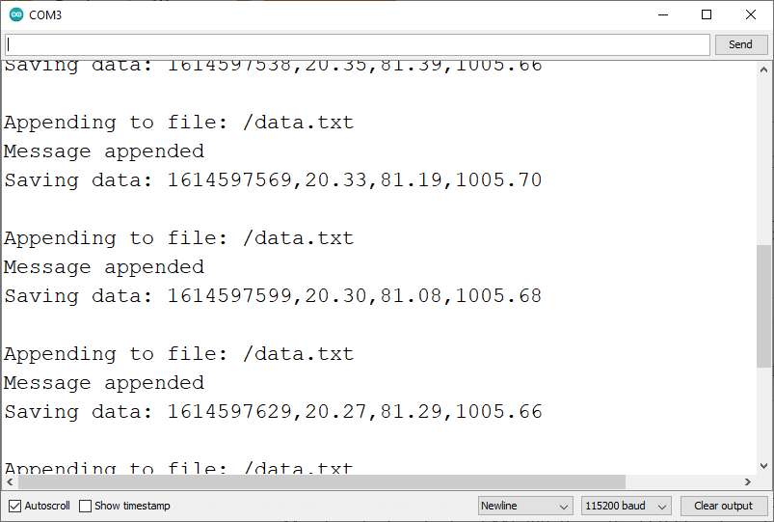
Let the project run for a while to gather some readings. Then, insert the microSD card on your computer, and you should have a file called data.txt with the sensor readings.
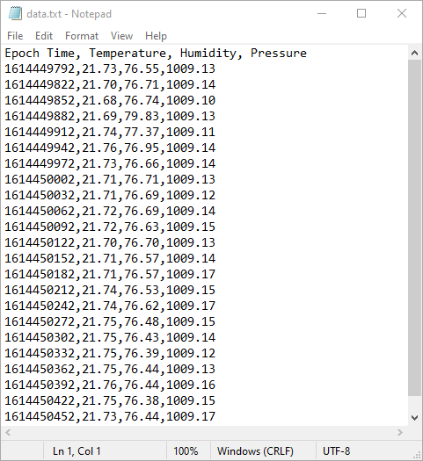

Example: ESP32 Web Server with Files from microSD Card
You can save the files to build a web server with the ESP32 on a microSD card (HTML, CSS, JavaScript, and image files). This can be useful if the files are too big to fit on the ESP32 filesystem, or it can also be more convenient depending on your project.
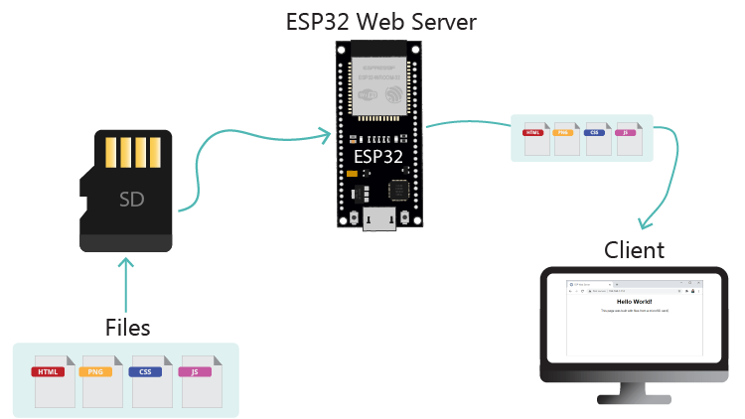
To show you how to do this, we’ll create a simple web server that serves a HTML, a CSS and a PNG file to build a web page and display a favicon.
Move the following files to your microSD card (click on the links to download the files):
- HTML file
- CSS file
- PNG file
Note: move only the files to the microSD card, not the folders.
Then, upload the following code to your Arduino IDE.
/*
Rui Santos
Complete project details at https://RandomNerdTutorials.com/esp32-web-server-microsd-card/

Permission is hereby granted, free of charge, to any person obtaining a copy
of this software and associated documentation files.

The above copyright notice and this permission notice shall be included in all
copies or substantial portions of the Software.
*/

#include <Arduino.h>
#include <WiFi.h>
#include <AsyncTCP.h>
#include <ESPAsyncWebServer.h>
#include "FS.h"
#include "SD.h"
#include "SPI.h"

// Replace with your network credentials
const char* ssid = "REPLACE_WITH_YOUR_SSID";
const char* password = "REPLACE_WITH_YOUR_PASSWORD";

// Create AsyncWebServer object on port 80
AsyncWebServer server(80);

void initSDCard(){
if(!SD.begin()){
Serial.println("Card Mount Failed");
return;
}
uint8_t cardType = SD.cardType();

if(cardType == CARD_NONE){
Serial.println("No SD card attached");
return;
}

Serial.print("SD Card Type: ");
if(cardType == CARD_MMC){
Serial.println("MMC");
} else if(cardType == CARD_SD){
Serial.println("SDSC");
} else if(cardType == CARD_SDHC){
Serial.println("SDHC");
} else {
Serial.println("UNKNOWN");
}
uint64_t cardSize = SD.cardSize() / (1024 * 1024);
Serial.printf("SD Card Size: %lluMB\n", cardSize);
}

void initWiFi() {
WiFi.mode(WIFI_STA);
WiFi.begin(ssid, password);
Serial.print("Connecting to WiFi ..");
while (WiFi.status() != WL_CONNECTED) {
Serial.print('.');
delay(1000);
}
Serial.println(WiFi.localIP());
}

void setup() {
Serial.begin(115200);
initWiFi();
initSDCard();

server.on("/", HTTP_GET, [](AsyncWebServerRequest *request){
request->send(SD, "/index.html", "text/html");
});

server.serveStatic("/", SD, "/");

server.begin();
}

void loop() {

}
Insert your network credentials in the following variables, and the code should work straight away:
// Replace with your network credentials
const char* ssid = "REPLACE_WITH_YOUR_SSID";
const char* password = "REPLACE_WITH_YOUR_PASSWORD";

Demonstration
After uploading the files to the microSD card and the sketch to your ESP32 board, open the Serial Monitor at a baud rate of 115200. Press the ESP32 on-board RST button. The ESP32 IP address will be displayed on the Serial Monitor.
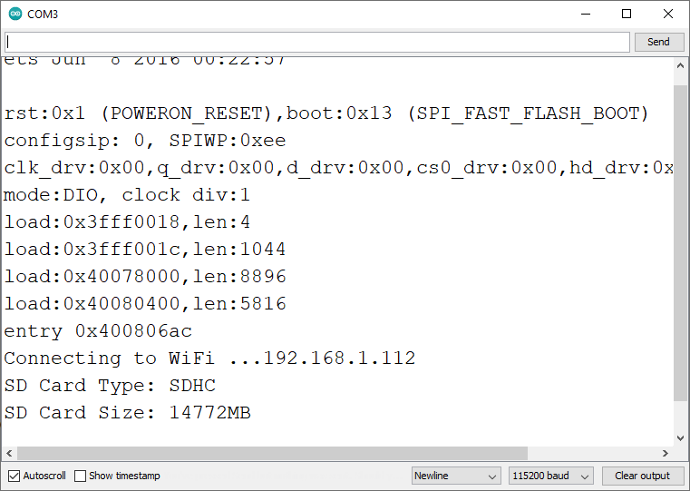
On your local network, open a web browser and type the ESP32 IP address. You should get access to the following web page built with the files stored on the microSD card.
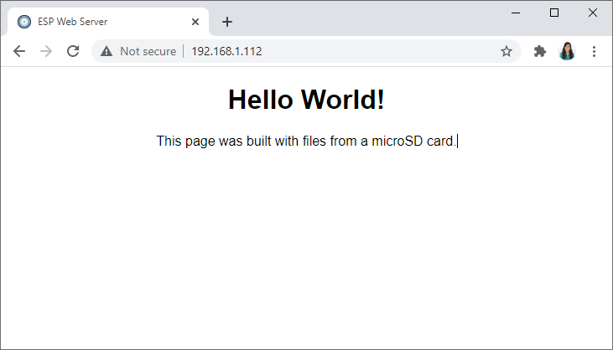
For a detailed explaination of this project, refer to the following tutorial:
- ESP32 Web Server with Files from microSD Card

Wrapping Up
In this tutorial, you’ve learned how to interface a microSD card with the ESP32 and read and write files. You’ve also learned how to use it for data logging projects or store files to serve in your web server projects.
For more in-depth projects with the microSD card, we recommend taking a look at the following:
ESP32 Data Logging Temperature to MicroSD Card
- ESP32 Web Server with Files from microSD Card
We hope you’ve found this tutorial useful. Learn more about the ESP32 with our resources:
- Learn ESP32 with Arduino IDE
- Build Web Servers with ESP32 and ESP8266
- More ESP32 Projects and Tutorials…

